Oliver Amparo

4/19/2021

This is the script and at the top. I made it so that it shows the date of when the command was run and below that it also says, “Information about the network”. Before running this script you might need to install net-tools. Then I run the ifconfig command to show information about the network. For example, things like the local ip address and the subnet mask. Then the ss -ltn shows all the open ports. The ss -s shows all the activity going on in the network at the comment. The last command I ran was to show information to show dns. After you run it a new file called netinfo.txt will be created and that is where your results are going to be.

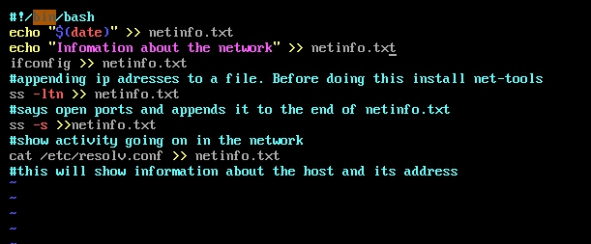

I ran the script on my ubuntu server. And when I did a file called netinfo.txt was created with the result of all the commands of the script.



I wanted to see the result of the script so I ran this in the command prompt cat netinfo.txt. And it shows the result of the script.

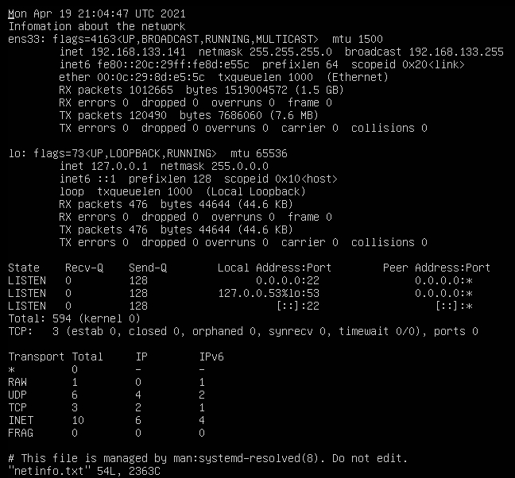

I did the same thing with the centos server and you can see the result below. It shows all the information about the network when it comes to open ports, ip addresses and it shows how much traffic is going on at a given time.

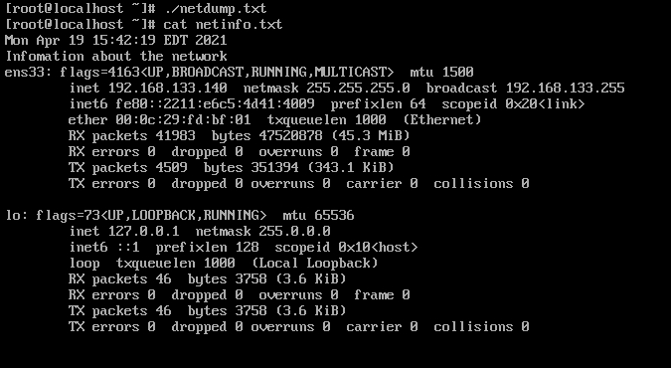

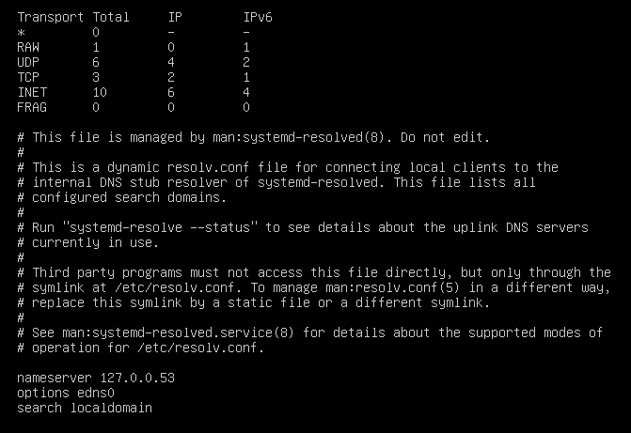

Link to github: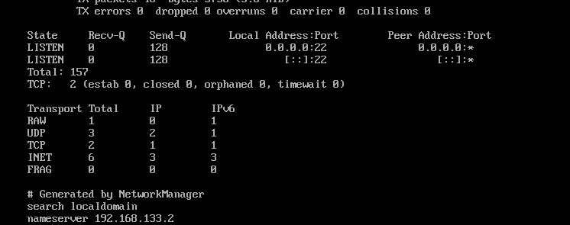

<https://github.com/Oliveramparo1/linux-admin/blob/main/networking>

Sources

<https://www.networkworld.com/article/3353039/how-to-configure-a-static-ip-address-on-linux.html>

<https://www.networkworld.com/article/3233306/more-ways-to-examine-network-connections-on-linux.html>

<https://wiki.debian.org/NetworkConfiguration>